expr1 = ("Eats", ("x", "Apple"))
expr2 = ("Eats", ("Riya", "y"))
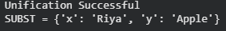

expr1 = ("Knows", ("x", "John"))
expr2 = ("Knows", ("Riya", "x"))

